http://jpninfo.com/9826

A Guide to Garbage Disposal in Japan
In most countries, other than Japan, throwing garbage could be as simple as flying a paper plane or tossing a ball in the air. Garbage is garbage and that’s the end of unwanted things. Put them in any container and bid goodbye to your waste.
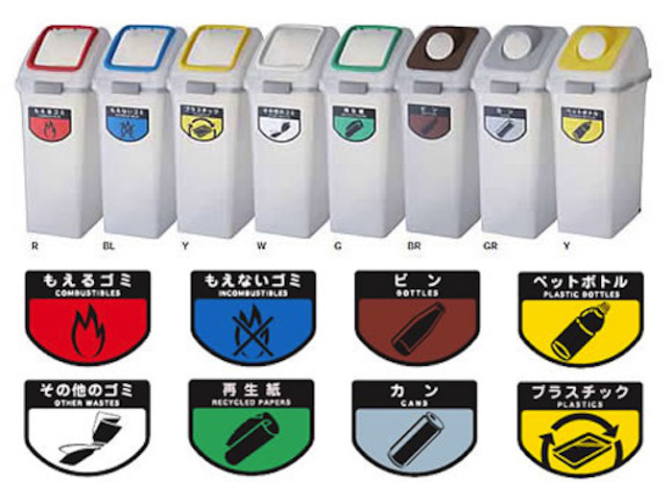
sociorocketnewsen.files.wordpress.com/
Most of the foreigners, who come to Japan for the first time, are surprised (and sometimes perplexed) to the very systematic throwing and separation of garbage in te Japanese recycling system. Each city has its own rules so you have to be careful. But, in general, the rules are pretty similar. In this article, I will talk about the rules of garbage disposal in the city where I live.
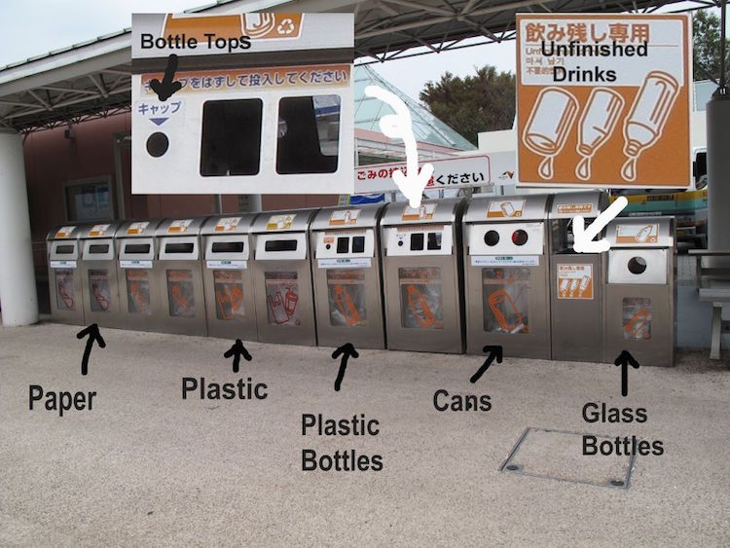
thealternative.in/

Garbage is classified into four types
1.Combustible
city.himi.toyama.jp/
Combustible trash or burnable trash, which is collected twice a week, includes paper wastes (toilet paper, diapers), plastic bags and wrappers (food wrappers, gift wrappers, candy wrappers, grocery bags), rubber and leather (bags, shoes, slippers, boots), tube and other plastic containers (toothpaste containers, cooking oil containers, soy sauce containers, ketchup containers, margarine containers, yogurt containers).
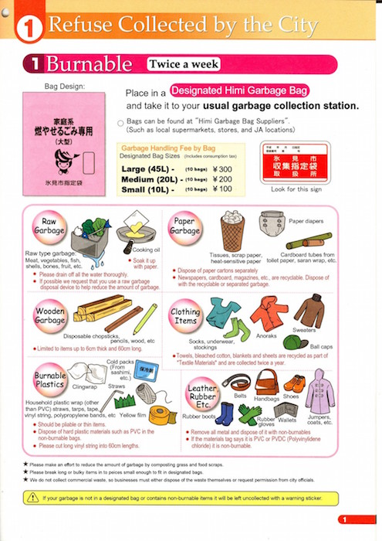

2. Incombustible
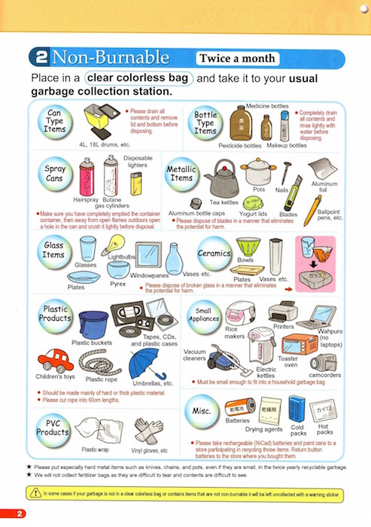
city.himi.toyama.jp/
Collected once a month, non-burnable trash includes long plastics (plastic cords, hoses, rope) other plastics (cassette and video tapes, floppy disks), ceramic wares (teacups, plates, flower pots, etc.), metals, glasses (flower vase, eyeglasses, glasses), and small appliances (flat iron, radio cassette, rice cooker, etc.)

3. Oversized Garbage
city.himi.toyama.jp/
This includes home furniture such as cupboards, bookshelves, sofa, bed, tables and other trash such as golf bag, over 50 centimetres stuffed toys, bicycles, below 60cc motorcycles, electric fans, vacuum, carpet and beddings.
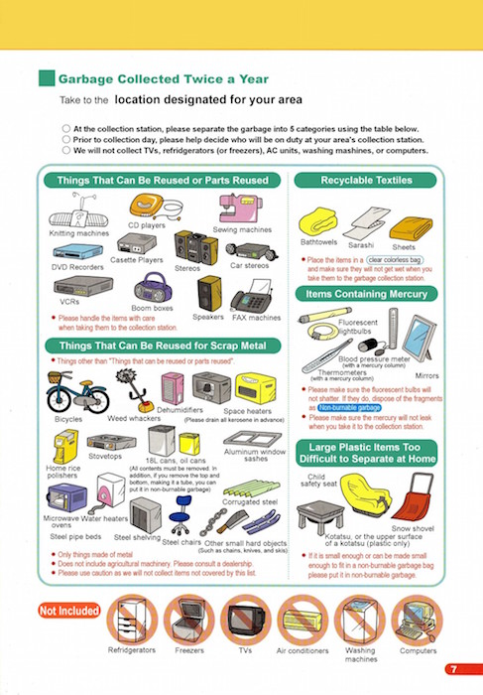
4. Bottles and Cans
city.himi.toyama.jp/
Bottles include empty glass containers (caps must be removed), tin cans, aluminum cans (juice and beer cans). These must be put in a separate garbage bag. Pet bottles (with the number 1 inside a triangle symbol) must also be in a separate garbage bag, with caps removed, washed and cleaned, and compressed (by stepping on it).
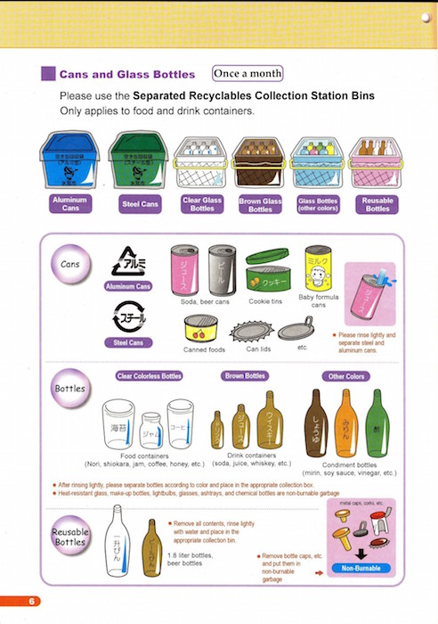
Rules
1. Designated garbage bags are classified into colors (each city has different colors) and are sold in supermarket or convenience stores.
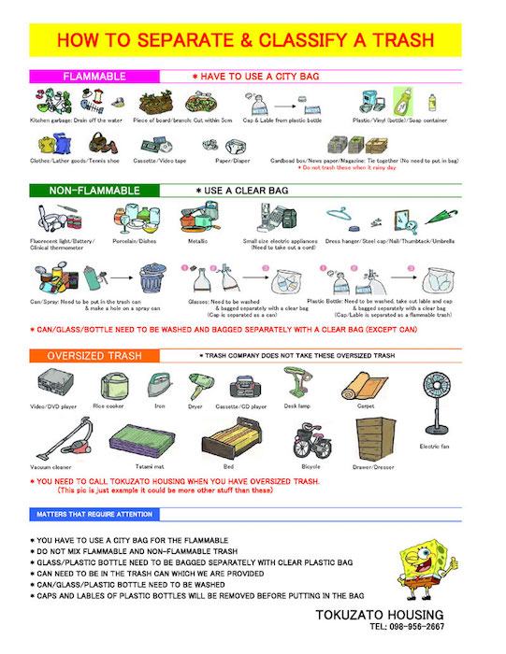
tokuzato-hsg.jp/
2. Garbage collection dates, collection area, and collection rules differ depending on the area.

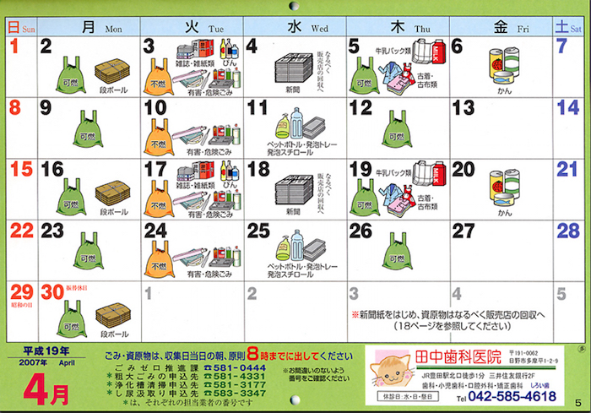
en.rocketnews24.com/
3. There is a specific fee (about ¥1,600.00 – ¥5,000.00) ($15 - $45) to throw away a broken television, air conditioner, washing machine or refrigerator.
4. Used cooking oil must be hardened and thrown as combustible garbage. It should not be poured down the drain.
5. Following the 3 R’s “Reduce, Reuse, Recycle” is highly encouraged.

Don’t Worry! Be Proud!
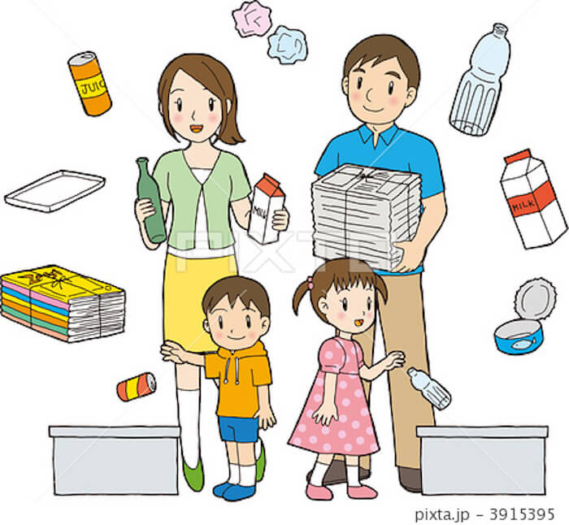t.pimg.jp/
For international students who will stay for a couple of months or years, universities conduct orientation about life in Japan and that includes how to, properly, dispose garbage. When you move to a new apartment, you will receive a booklet on proper garbage disposal in your area. It seems confusing to follow at first but once you get used to it, it is no sweat at all. In the end, it will give you a sense of pride for being a part of a clean Japan.
Japanese Recycling Symbols
​