http://green.blogs.nytimes.com/2011/10/24/disposable-chopsticks-strip-asian-forests/?_r=0
Energy, the Environment and the Bottom Line

Disposable Chopsticks Strip Asian Forests
By
RACHEL NUWER

OCTOBER 24, 2011 4:22 PMOctober 24, 2011 4:22 pm
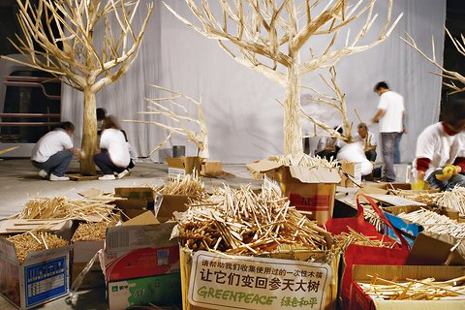Liu Xiaohang, GreenpeaceStudents in Beijing assemble a “disposable forest” to highlight the deforestation issue.
Festival season in Japan is a sensory delight. Taiko drums bang while fireworks blaze overhead, delighting kimono-clad onlookers. Perhaps most central to the Japanese festival experience, though, is the food: sizzling meat on a stick, octopus balls and globs of at least four kinds of noodles are only a few of the delicacies on offer.
By the end of the night, the detritus from all this collective munching includes thousands of used wooden chopsticks destined for tomorrow’s garbage pickup.
Though the chopstick is the quintessential cutlery choice throughout most of Asia, Japan and China in particular seem prone to using the disposable variety. In China, smaller restaurants prefer disposables while larger ones tend to go with plastic. In Japan, disposables are found even at nicer sit-down establishments.
Visit a run-of-the-mill sushi bar in New York or London and you’ll probably find wooden chopsticks at your disposal there, too. But if you’re in the mood for Vietnamese food, you’ll probably be dining with the plastic variety, while Korean restaurants tend to go with metal.
So, what’s the big deal?
Each year, the equivalent of 3.8 million trees go into the manufacture of about 57 billion disposable pairs of chopsticks in China, according to statistics from that nation’s national forest bureau. About 45 percent of disposable chopsticks are made from trees like cotton wood, birch, and spruce, while the remainder are made from bamboo.
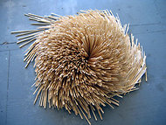Donna Keiko Ozawa,
The Waribashi ProjectThe artist Donna Keiko Ozawa fashions tightly composed works from used chopsticks.
Half of the disposables are consumed within China. Of the other half, 77 percent is exported to Japan, 21 percent to South Korea and 2 percent to the United States.
Chopsticks add to a plague of regional deforestation. According to a 2008 United Nations report, 10,800 square miles of Asian forest are disappearing each year, a trend that must be arrested to fight climate change, given the vital role trees play in absorbing carbon dioxide.
Activists argue that the disposable chopstick habit could gradually be phased out on an individual basis. Chopstick sets complete with a simple or decorative case are sold at many stores and are easy to put in a purse, knapsack or briefcase, they note.
In China, organizations like Greenpeace East Asia are trying to raise awareness of the issue. In December, 200 students from 20 Chinese universities collected 82,000 pairs of used disposable chopsticks from Beijing restaurants. With the discarded utensils, they built four trees, each 16 feet high, to create a “disposable forest.”
The project was featured in a busy pedestrian mall in Beijing, and the students encouraged 40,000 passersby to sign a petition rejecting disposable chopsticks. “Imagine thousands of people passing by that area every day,” said Aihong Li, a spokeswoman for Greenpeace in Beijing. “It was quite shocking for people to see these images.”
Some American artists have also drawn attention to the dimensions of the waste. Donna Keiko Ozawa, a San Francisco artist, collected over 170,000 used chopsticks for her continuing waribashi project, a reference to the Japanese word for disposable chopsticks. Her works consist of seemingly haphazard but tightly constructed abstract forms built entirely from used chopsticks.
“Japanese restaurants in particular have a tendency to use disposables,” she said. “They weren’t composting or recycling.”
In 2007, China imposed a tax on wooden chopsticks with the goal of helping the environment. After that, Japan — which boasts one of the world’s highest forest coverage rates at 69 percent — simply began relying more on other suppliers like Vietnam, Indonesia, and Russia rather than phasing out disposables.
For a country otherwise obsessed with recycling — a typical Japanese kitchen often devotes half its space to multiple trash bins for meticulously sorting recyclables — the chopstick phenomenon may seem puzzling. Cost isn’t the driver: restaurants investing in reusable chopsticks at $1.17 a pop actually save money in cost-per-use by comparison with disposables.
Restaurant reusables normally have a life span of about 130 meals. Disposables cost about 2 cents in Japan, so the equivalent 130 disposable pairs cost about $2.60.
Of course, some customers may balk at eating with reusables, citing sanitary concerns.
But disposable chopsticks pose risks of their own for consumers and the environment, Greenpeace says. While production standards exist in China, it says, supervision is sometimes nonexistent, especially in small factories. Industrial-grade sulfur, paraffin, hydrogen peroxide and insect repellent are among the harmful chemicals that Chinese media investigations have exposed during production.
Paraffin is a known carcinogen, and hydrogen peroxide can harm the digestive system. Chopsticks irresponsibly disposed of can contaminate water and soil quality.
While there has been no Japanese legislation to address the issue, a few on-the-ground changes are gaining popularity. Some restaurants now stock plastic chopsticks, although they keep a stash of disposables on hand in case customers request them.
At the ubiquitous convenience stores throughout Japan, cashiers now ask if customers need chopsticks rather than sticking them into checkout bags by default. Certain restaurants also offer discounts or free tea for people who bring their own utensils.
In China, 2,000 Beijing and Guangzhou restaurants have sworn off wooden chopsticks, and the Web site Fantong reports which restaurants are committed to reusables.
Last year, the Chinese government issued a notice urging restaurants to go green, although Greenpeace said that the notice did not include specific measures for reaching that goal.
“Generally speaking, more and more college students and white-collar workers are bringing their own chopsticks for meals,” Ms. Li of Greepeace says, “though in the greater sense this is still a big problem.”
This issue may not be on the radar for many American consumers. But as awareness spreads, you may notice people pulling out their own chopsticks when they dine at a noodle joint, or declining disposables when they grab a bento to go.
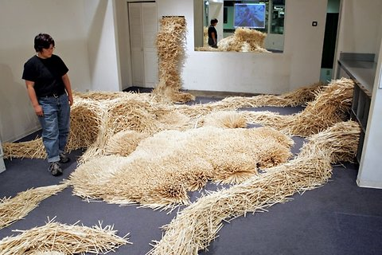Sibila SavageDonna Keiko Ozawa in her “Waribashi” installation in San Francisco.

