NAME___________________________________________________________HOMEROOM________________

Please complete this form with a Parent/Guardian, Grandparent, Aunt, Uncle Etc.

What is CULTURE?
The behaviors and beliefs characteristic of a particular social, ethnic, or age group: the youth culture, Italian culture etc. No individual is born with a sense of his/her culture. He/she has to learn it.

What country(s) do your ANCESTORS come from (i.e. Africa, Korea, India, Italy, etc)?

What are some examples of YOUR ancestors culture?

Choose and research at least 3 characteristics of your ANCESTRY (family or ancestral descent) from the below list. Write down facts and/or examples of the specific characteristic.

Music/Dance
Artwork
Customs/Tradition
Fashion
Food
Architecture
Beliefs/Rituals
Literature

1.____________________(characteristic)

_______________________________________________________________________.

2.____________________(characteristic)

_______________________________________________________________________.

3.____________________(characteristic)

_______________________________________________________________________.

The following will be completed IN CLASS….
You will be creating a ceramic game board i.e.tic-tac-toe based off of a characteristic of your ancestor’s culture.

For example…My ancestors are from Italy. Clothing/Fashion is very important to the Italian culture. They believe that your appearance extends to the aura you project (i.e. confidence, style, demeanor, etc.). I might choose to design a shoe for my game board. The game pieces might be clothing accessories (i.e. belts, bags, hangers).

PLANNING YOUR DESIGN FOR THE GAME BOARD…

In your SKETCH BOOK…Create a realistic image or symbolic image to represent TWO of the THREE above characteristics of your ancestor’s culture that you researched. You will choose one of these designs for your ceramic game board.

Design a game…
- What type of game i.e tic-tac-toe or create your own?
- What will your game board look like?
- How many game pieces? What will they be
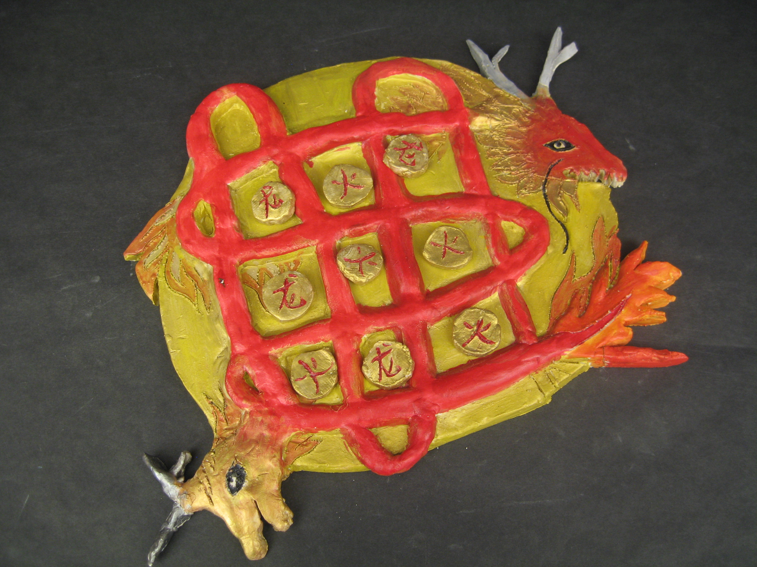
Chinese Cultural Game Board by Kristine Lai

